**Let.Me.Out.**

After attending several Music Current festivals organized by Dublin Sound Lab in 2019, I was amazed and inspired by commissioned works that were heavily involved with electronic and choreographic elements. The work *Sideshow* by Steven Kazuo Takasugi has highly motivated me to compose music in combination with electronic elements and mime acting. Hence, this led me to compose a work for accordion and tape (processed electronic sound), with mime acting involved.

The work is structured in ternary form with a coda. The first section introduces percussive textures that imitate the electronic sound world. Also, the performer is asked to mime robotically, to create the cold and insecure feelings. The second section is more pitch-based in comparison to the first section, while the mime acting becomes more confusing and humorous. The first section returns in a more complicated manner and it combines the material from second section in the second half. Lastly, the work ends with a chaotic coda with the all materials from the work smashed/collided(?) together.

The rhythm is more important in this work, whereas the pitch material is secondary. This work applies the single line stave, found in the notation of *Workers’ Union* by Louis Andriessen, which represents the middle register of the accordion in both hands(?). However, this work mixes the single line stave with the conventional stave to indicate notes.

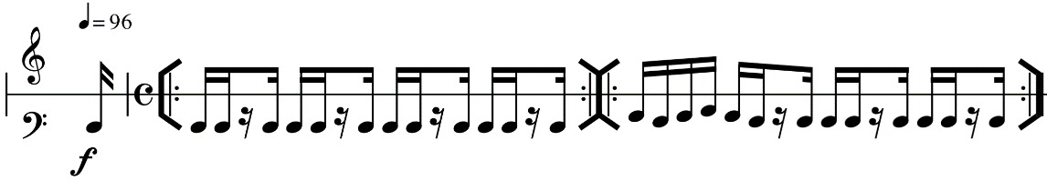

Figure 1: Workers’ Union’s notation

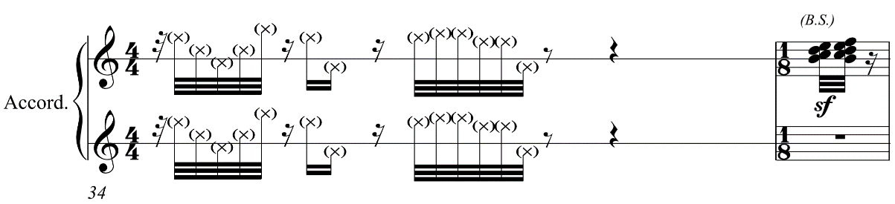

Figure 2: Let.Me.Out.’s notation

The process of making the tape requires a lot of collaborations with the performer, as several sounds are needed to be recorded from the accordion. However, the meetings were unexpectedly cancelled, due to the Covid-19 lockdown. Hence, I made a provisional tape and obtained all the sounds through freesound.org and Sibelius’s sound library. Although some sounds are hard to imitate, such as button clicks, I used the equalizer and the reverb to change the timbre of the sample to make the sound as similar as possible through Cubase.

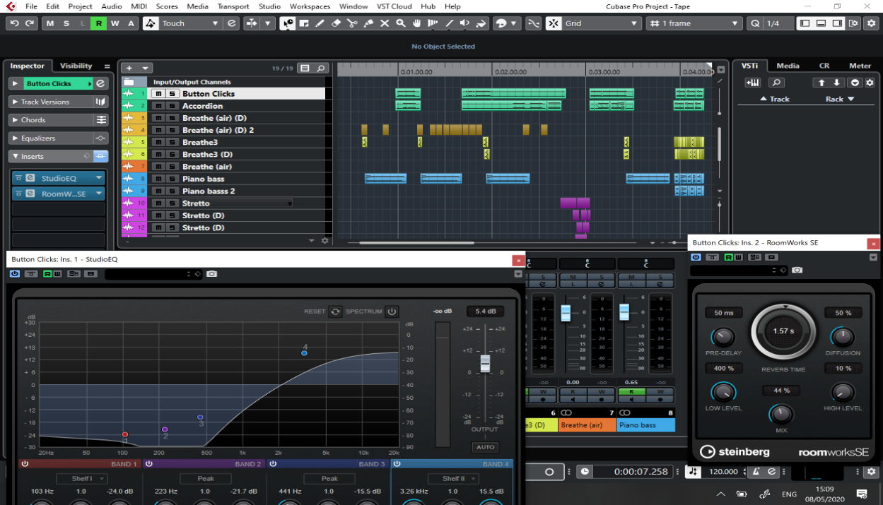

Figure 3: Equalizer and Reverb are employed in Cubase

The sound effect of the performance direction “*air sound with gaps*” is inspired by flickering lights. The intention of this is to turn the visual effect into an audio effect, to create a disordered feeling.

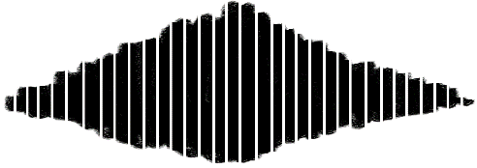

Figure 4: Example of air sound with gaps

Furthermore, a legend is included in the piece, to clarify all the unusual notations.